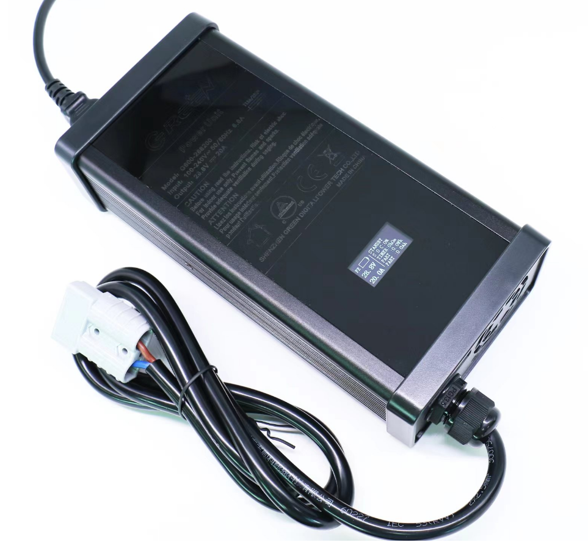






Features ■ Applications

• Charger forlithiumbatteries (Li-ion,LiFePO4and lithiummanganese) and Lead-Acid batteries
• Built- in 4 stage charging curve(For Lithium batteries) and 3 stage charging curve(For Lead-Acid batteries )
• Universal AC input / Full range(90-264V~)
• Built- in active PFC function
• Protection: Short circuit / Over voltage /Over temperature /Battery over voltage / Battery reverse polarity protection
• 1 years warranty
• Radio system backupsolution
• Electric scooter charger
• Surveillance system
• Electric motorcycle\Electric sweeper

Description
G600isasingle output 600Ｗ AC/DCdesktop type charger with 4 and 3 stage charging curve In addition to the embedded pre-defined charging curves,the default curve is programmable and thus able to accommodate different types of batteries,such as Lead- acid batteries ( gel,floodedand AGM) and Lithiumbatteries(Li-ion,LiFePO4 andLithium manganese).G600 can be set different charging voltage value, charging current value and charging end current value through USB, according to customer's own requirements. The LCD screen of G600 can display the voltage, current capacity, and preset voltage and current.

ModeEncoding

G600-XXXYYY
Rated currentRated voltage Series name

SPECIFICATION（Lead-Acid battery charger）
MODEL |  | G600-147340 | G600-294200 |  |  | G600-441136 |  | G600-588102 |  | G600-735081
OUTPUT | Charge voltag (High voltage) | 14.7V±1% | 29.4V±1% |  |  | 44.1V±1% |  | 58.8V±1% |  | 73.5V±1%
OUTPUT | Charge voltage range | 10-14.7V | 17.5-29.4V |  |  | 25-44.1V |  | 35-58.8V |  | 42.5-73.5V
OUTPUT | Float charge（Low voltage） | 13.8V±1% | 27.6V±1% |  |  | 41.4V±1% |  | 55.2V±1% |  | 69V±1%
OUTPUT | Charge current | 34.0A±10% | 20.0A±10% |  |  | 13.6A±10% |  | 10.2A±10% |  | 8.1A±10%
OUTPUT | Charge-end current | ≤7A ±20% | ≤4A ±20% |  |  | ≤2.7A ±20% |  | ≤1A ±20% |  | ≤1.6A ±20%
OUTPUT | Rated power | 499.8W | 588W |  |  | 599.76 |  | 599.76W |  | 595.35W
OUTPUT | Recommended battery capacity  Note.3 | 60 - 200Ah | 40 - 150Ah |  |  | 30 - 100Ah |  | 20 - 80Ah |  | 15 - 60Ah
OUTPUT | Leakage current from battery (Typ.) | ≤1mA
CHARGE INDICATOR | LCD display | Display voltage, current, capacity
COMMUNICATION FUNCTION | USB / CAN / 485 Note.1 | The battery type (Lead acid, Lithium battery,LiFePO4 battery), charging voltage and charging current can be set by USB interface, Communication with external devices via CAN or RS485.
INPUT | Rated input voltage | 100 - 240VAC 50 / 60Hz
INPUT | Input voltage range Note.4 | 90 - 264VAC
INPUT | Power factor (Typ.) | PF>0. 98@AC100V,Full load
INPUT | Input current (Typ.) | 5.8A@115VAC 2.8A@230VAC
INPUT | Inrush current (Typ.) | Cold start75A @230VAC
INPUT | Standby input power | < 2.5W
INPUT | Efficiency (Typ.) | 90% |  | 92% |  |  | 92% |  | 93% |  | 93%
PROTECTION | Short circuit Note.5 | Protection type : Shut down output
PROTECTION | Over voltage | >15.5V*N
PROTECTION | Reverse polarity | By internal relay
PROTECTION | Over temperature | Shut down output, recovers automatically after temperature goes down
ENVIRONMENT | Working temperature | -10 - +40℃ (Refer to " Derating Curve")
ENVIRONMENT | Working humidity | 0 - 90% RH
ENVIRONMENT | Storage temperature, humidity | -40 - +70℃, 0- 95% RH
ENVIRONMENT | Cooling | Fan convection
ENVIRONMENT | Vibration resistance | 10-50Hz,2G10min.1cycle,60min.eachalongX,Y,Zaxes
SAFETY&EMC(Note.6) | Max. temperature rise | < 40℃ on casing
SAFETY&EMC(Note.6) | Hi-Pot Insulation | i/p to o/p: 3000V (1 min)
SAFETY&EMC(Note.6) | Safety standards | IEC62368-1
SAFETY&EMC(Note.6) | EMC Emission | Parameter |  |  | standard |  |  |  |  | Test Level I Note
SAFETY&EMC(Note.6) | EMC Emission | Conducted |  |  | EN55032FCCPART15 |  |  |  |  | Class B
SAFETY&EMC(Note.6) | EMC Emission | Radiated |  |  | EN55032FCCPART15 |  |  |  |  | Class B
SAFETY&EMC(Note.6) | EMC Emission | Harmonic Current |  |  | EN61000-3-2 |  |  |  |  | .....
SAFETY&EMC(Note.6) | EMC Emission | Voltage Flicker |  |  | EN61000-3-3 |  |  |  |  | .....
SAFETY&EMC(Note.6) | EMC IMMUNITY | EN61000-4-2，EN61000-4-3，EN61000-4-4，EN61000-4-5，EN61000-4-6，EN61000-4-8，EN61000-4-11
OTHERS | MTBF | 30000H
OTHERS | Dimension | 240*117*66mm (L*W*H)
OTHERS | Weight | 1500g
NOTE | - Modification for charger specification may be required for different battery specification. Please contact battery vendor and Green digital power for details.  - All parameters NOT specially mentioned are measured at 230VAC input, rated load and 25℃ of ambient temperature.  - This is Green suggested range. Please consult your battery manufacturer for their suggestions about maximum charging current limitation.  - Derating may be needed under low input voltages. Please check the derating curve for more details.  - This protection mechanism is specified for the case the short circuit occurs after the charger is turned on.  - The battery charger is considered as an independent unit, but the final equipment still need to re-confirm that the whole system complies with the EMC directives. For guidance on how to perform these EMC tests, please refer to "EM I testing of component power supplies."

Block Diagram


DC-
DC+
AC
EMIFILTER
&
RECTIFIERS

PFC
CONTROL

FG
POLARITY
REVERSE PROTECTION
PFC
CIRCUIT

PWM
CONTROL
RECTIFIERS
&
FILTER
POWER SWITCHING

DETECTION CIRCUIT

Derating Curve

static Characteristics

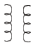

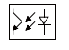

60

70

80

90

LOAD (%)
100
150

100

90

120

220

240

264

LOAD (%)
10

-10

20

40

60

80

100
20

40

50

60

AMBIENTTEMPERATURE(℃)

30

AC input voltage (V)

Function Manual

  - ChargingCurve

◎ 4stage charging curve(Li-ion battery charger)
Li-ion N*4.2V
Current
Voltage
Constant voltage
Cut off
Constant current
Pre-charge
Time

LiFePO4 N*3.6V

◎ 3stage charging curve(Lead-Acid battery charger)
Current
Voltage
N*14.7V
N*13.8V
Constant voltage(H)
Constant voltage(L)
Constant current
Time

  - LCD display

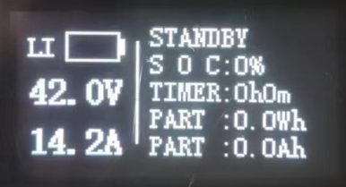

Mechanical specification

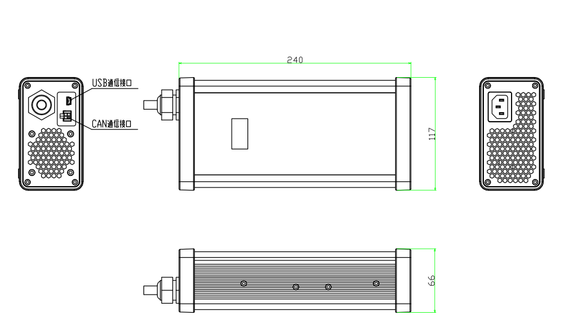



CommunicationTerminal Pin No. Assignment
- When using CAN communication
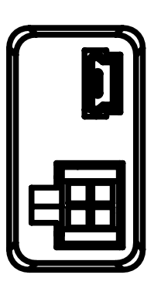
Pin No. | Assignment
1 | CANH
2 | 5V+
3 | CANL
4 | 5V-

- When using RS485 communication

Pin No. | Assignment
1 | RS485-B
2 | 5V+
3 | RS485-A
4 | 5V-

